Learning at home Art and Design Technology

Theme Spring Daffodils
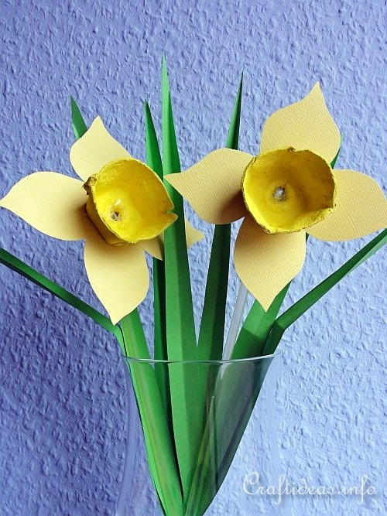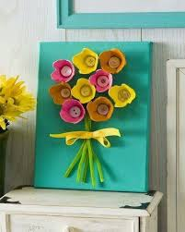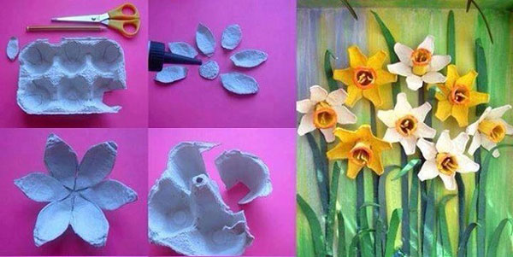
Make some egg box Spring flowers
Daffodils or tulips
Sketch a still- life of a vase of flowers or look up close at flowers and create a flowering plant study cross curricular /Science

