Can I complete the quiz after reading the United Kingdom (UK) of Great Britain (GB) and Northern Ireland Fact Sheet?

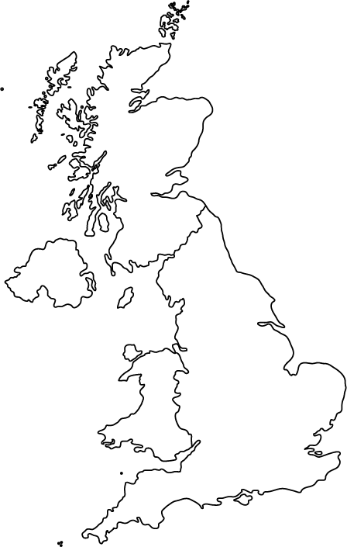

The United Kingdom (UK) is made up of 4 countries.

The four countries are Scotland, England, Wales and Northern Ireland.

The British Isles is the name given to the two large islands and many smaller ones. The large islands are the United Kingdom and The Republic of Ireland.

Great Britain is famous for fish and chips.

The North Sea, the Irish Sea, the English Channel and the Atlantic Ocean surround the British Isles.

Questions

1. Which 4 countries make up Great Britain?

2. Name a ‘sea’ near the United Kingdom.

3. Name an ‘ocean’ near the Republic of Ireland.

4. What is the English Channel?

Scotland – Fact Sheet

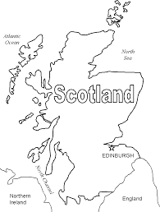

Scotland is north of England.

Scotland is famous for bagpipes, tartan and kilts.

Shortbread and haggis are Scottish foods.

There are 700 islands in Scotland.

Edinburgh is the capital city of Scotland.

St Andrew’s Day is celebrated in Scotland.

Scotland has spectacular scenery and has Britain’s highest mountain (Ben Nevis).

The Scottish flag is called the Saltire.

England - Fact Sheet

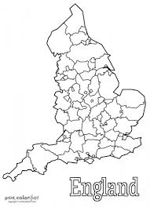

England is bordered by Scotland and Wales.

A ‘Full English’ is a big breakfast including bacon, eggs and sausages.

London is the capital city of England.

England is the largest country in the UK.

St George’s Day is celebrated in England.

England has some beautiful national parks including the Yorkshire Dales and the Lake District.

Wales – Fact Sheet

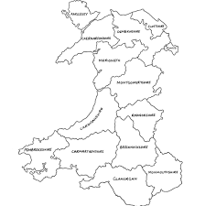

One quarter of the people in Wales can speak Welsh.

There are many mountains in Wales.

‘Welsh Rarebit’ is made from bread and cheese.

The Welsh flag has a dragon on it.

Cardiff is the capital city of Wales.

St David’s Day is celebrated in Wales.

Wales has a beautiful natural landscape.

Northern Ireland – Fact Sheet

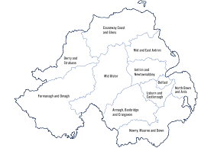

Northern Ireland is the smallest country in the UK.

Northern Ireland is the top part of the Republic of Ireland (ROI).

The famous ship ‘The Titanic’ was built in Belfast in 1912.

Soda bread and Irish Stew (made with meat, potatoes and onions) are Irish foods.

Belfast is the capital of Northern Ireland.

Dublin is the capital city of the Republic of Ireland.

St Patrick’s Day is celebrated in Ireland.

‘The Giant’s Causeway’ is an amazing rock formation, it attracts visitors from around the world.

**The United Kingdom and Northern Ireland Quiz**

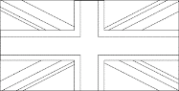 What is the capital city of England?

****What is the name of the famous Scottish fabric?

****What is Welsh Rarebit made with?

****What is the capital city of Wales?

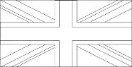Which is the smallest country in the British Isles?

****What is the capital city of Northern Ireland?

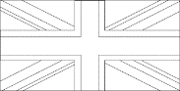Which country’s flag has a dragon on it?

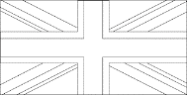What is the capital city of Scotland?

****Which sea is between Ireland and England?

****Which country is the largest in the UK?

****Name the highest mountain in the British Isles.

****Where is ‘The Giant’s Causeway’