Question marks
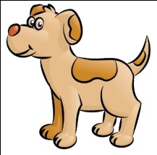
Can you put the question mark in the right place?
Where has the dog gone
Who is star of the week
Can you fill in the missing question word from the word bank?
______________ are you having for tea
Can
How
What
______________ are you
Is
When
Why
______________ you help me
______________ is coming to the party
Could
What
Who
______________ day is it today
______________ you pass me a pencil please
Question marks
Can you fill in the missing question word from the word bank?
______________ are you having for tea
Can
How
What
______________ are you
Is
When
Why
______________ you help me
______________ is coming to the party
Could
What
Who
______________ day is it today
Do
Would
______________ you pass me a pencil please
______________ you like peas
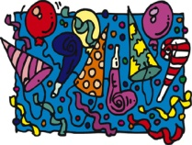
______________ it cold outside
______________ you like a sweet

