Term: Spring 2. | Teacher & Year Group: Miss McInnes, Class 3.
Home Learning.
Dear Parent/Career,
In this pack you will find work covering Maths, English, Science, Geography, R.E, ART and SCARF.
It is important that your child accesses TT-Rockstars and continues to read as much as possible. They can read books, magazines, recipe books or even put subtitles on a programme they are watching.
If you have access to Youtube there is a daily exercise workout with The Body Coach https://www.youtube.com/watch?v=Rz0go1pTda8 It will be dated on his channel so you can do one every day at 9am live or follow the video at any time during the day.

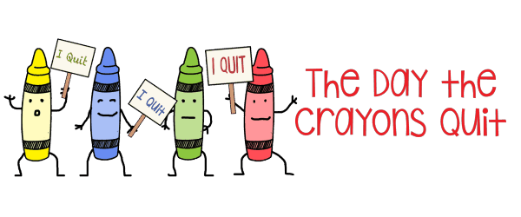  English |  | This week I have set daily English tasks based on the fantastic book ‘The Day the Crayons Quit’ I’m sure you’re going to love it! I will also upload a comprehension and some Grammar work additional to this. Remember to keep practising your cursive handwriting, so it is lovely and neat for when we come back to school.  The Day the Crayons Quit – Daily Activities.  Monday Listen and watch the story: https://www.youtube.com/watch?v=xkMmfIwOix8 Can you draw each crayon and write a sentence using a simile for each of the crayons?  Tuesday Read the letter to Duncan from red crayon to retrieve the answers for the following questions: 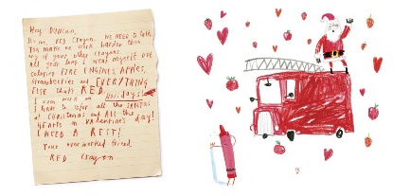 - How had Duncan used this crayon? - How does this make the crayon feel? - What does the crayon want Duncan to do? - How does the crayon try to persuade Duncan to use the crayon differently? - What could/would you do to make the crayon happy?  Wednesday Choose 2 crayons and write a short paragraph describing both crayons and then compare them using comparative language such as whereas, in comparison to, however, similarly, etc. Use the information from the letters in the story to help you (watch the video again). Try to use adjectives, connectives and similes to compare them. E.g. The yellow crayon is as bright as a light and therefore better to use for colouring the sun. In my opinion, the orange crayon is more like a fire and is a very warm colour.  Thursday Create a small dialogue between two or three of the crayons about wanting to quit. What might they say to each other? How might they say it? Remember to punctuate your speech correctly. “Duncan doesn’t look after me very well, I used to be so tall now I’m all short and stubby” sighed Barry the Blue Crayon.  Friday Today, you are Duncan. This morning, you got up to go and draw using your pack of cool crayons. Instead, you found a pile of letters from your crayons expressing their feelings and quitting as your colouring partner. You were so upset that you couldn’t colour but most of all upset that you didn’t treat your crayons very nicely. Write a diary entry about your day, from waking up to finding those letters. Express your thoughts and feelings. Remember a diary entry doesn’t have any speech. You should write it in first person as Duncan, at the beginning you need to write the date and then Dear Diary, write the entry in past tense (it has already happened), tell the events in order, describe your feelings, include rhetorical questions and use time connectives.  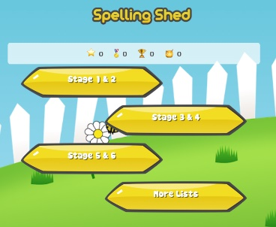  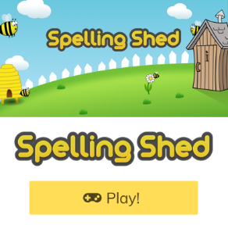  Practise spellings on Spelling Shed, go on to ‘web game’ and click on stages 3&4. The focus is ‘le’ at the end of a word.  Scroll down for extra sheets to help you with this work, grammar sheets and a reading comprehension.
Maths |  | Scroll down for Maths activity sheet 8 questions to complete over the week. If you can’t print, rewrite these questions up into your home learning book with the correct answers.  Go on to TT-Rockstars once a day on our group! I may be on there myself to challenge you one day 😊
Science |  | We started looking at electricity in Science, we looked at different forms of electricity and made lists of different items that needed electricity to work.  Have a look around your house and draw or write a list of electrical objects you can see inside your house. Think about whether they use mains or batteries to power them.
Art |  | 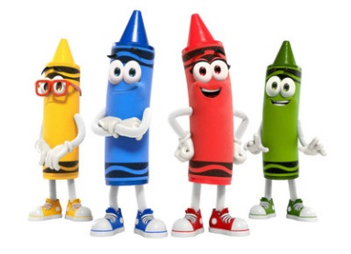  Design your own crayon making machine!  Create your own invention, draw a machine that makes crayons! Then explain how it works using bossy verbs to give clear instructions.  Watch this video on how crayons are made and see if you were close.  https://youtu.be/4C-HGq12tzk
Religious Education |  | https://www.youtube.com/watch?v=Wnbo2AmS3OI – watch this video of the Easter Story.  Can you write your own Haiku poem based on the events from the Easter story?  As a challenge you could write a Haiku poem for each event, Palm Sunday, Good Friday and Easter Sunday.
Geography |  | Can you research the bodies of water in the Lake District and choose your favourite?  You need to create a poster drawing your favourite lake and write several facts about it.
SCARF |  | Create your own rainbow poster to remind people that storms don’t last forever, and we will soon return as we were.  Make someone smile by putting your picture up at a window.

English
Read the letter to Duncan from Red Crayon and then answer the 5 questions.
These will improve your retrieval and inference skills.
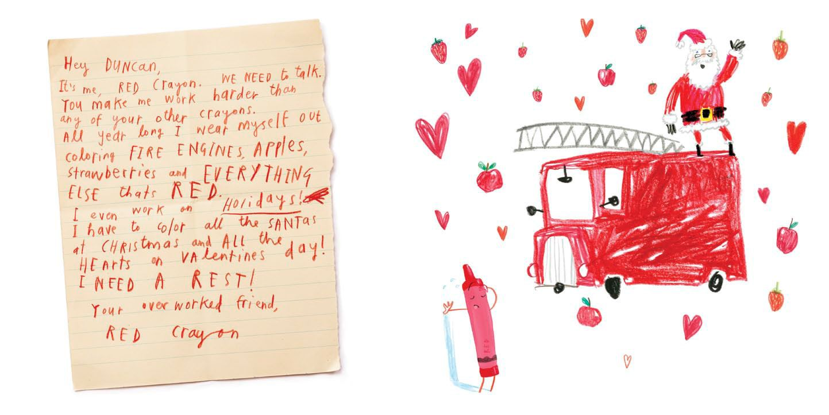

- How had Duncan used this crayon?
- How does this make the crayon feel?
- What does the crayon want Duncan to do?
- How does the crayon try to persuade Duncan to use the crayon differently?
- What could/would you do to make the crayon happy?

Year 3 Grammar
Rewrite and answer in homework book 😊

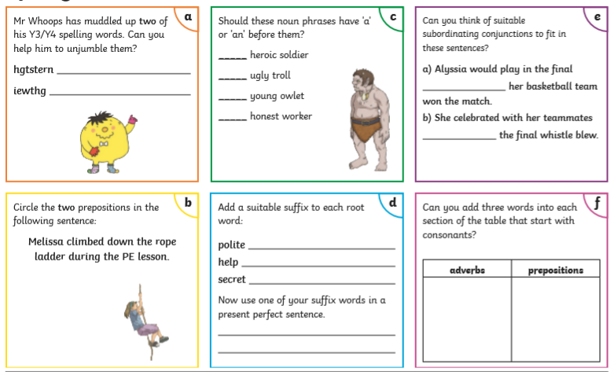

Reading comprehension
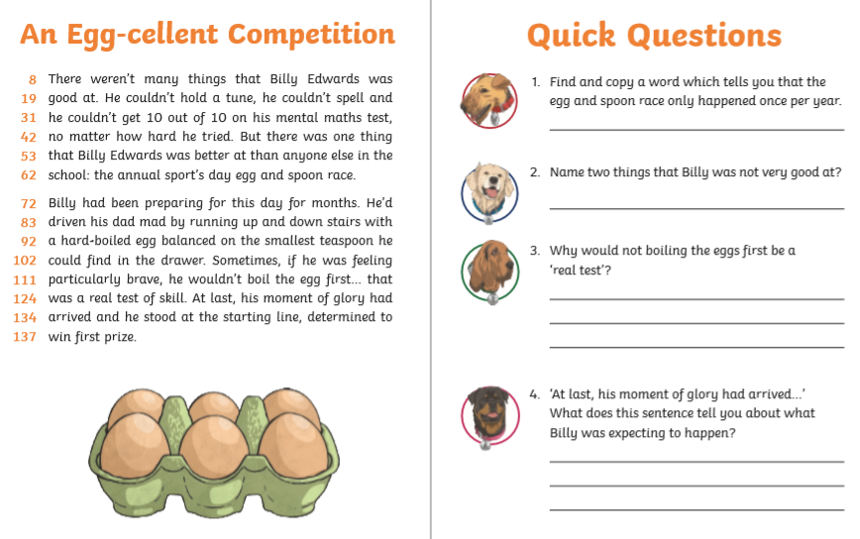
Spellings

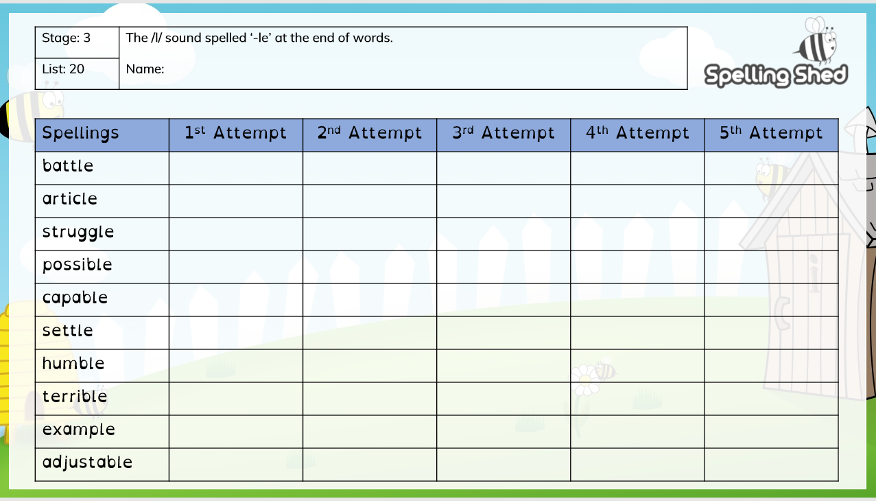

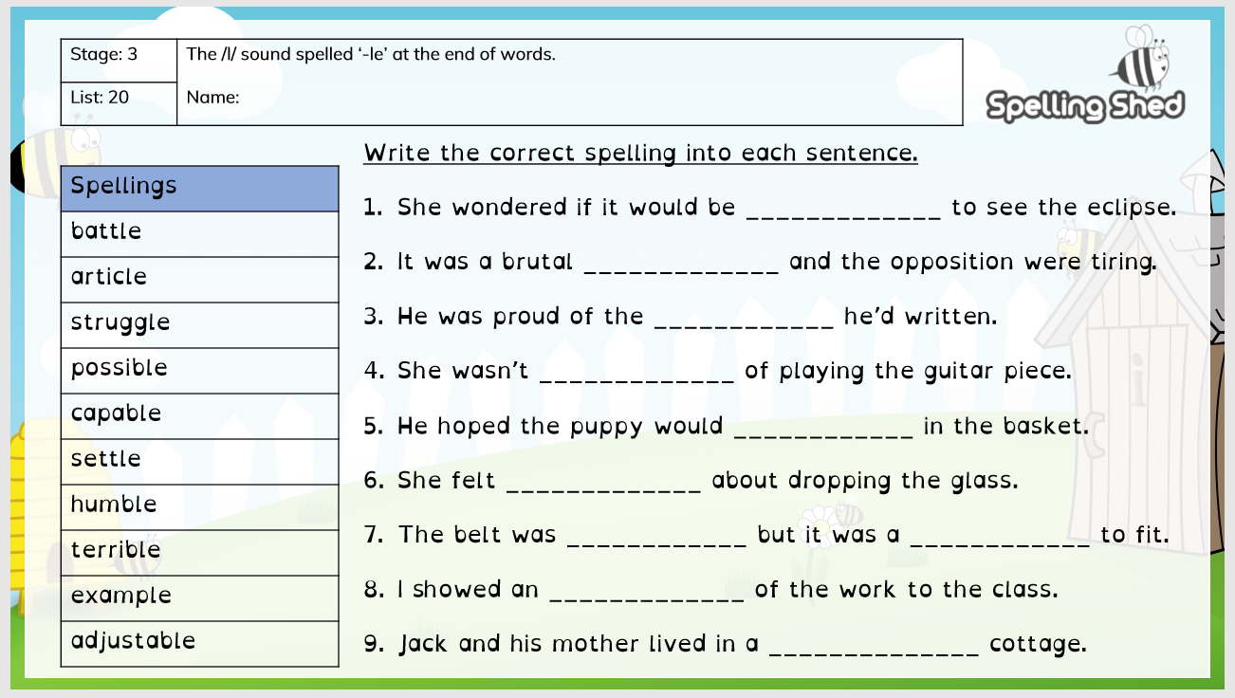

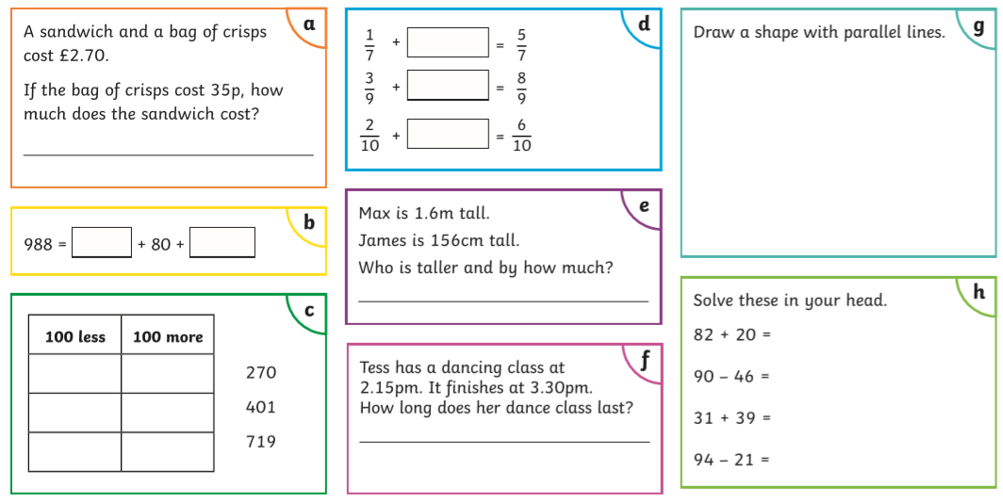
Maths
Year 3 Maths Mat

Rewrite and complete these questions in your home learning book.

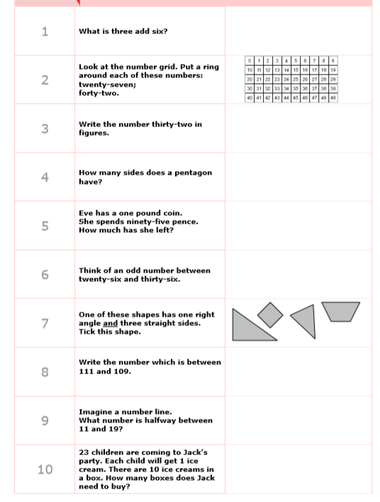

Science
Draw or write a list of electrical objects you can see inside your house. Think about whether they use mains or batteries to power them.
Battery | Mains

