Week 3
Day 1
1 | one
2
3
4
5
6
7
8
9
10
11
12
13 | thirteen
14
15
16
17
18
19
20 | twenty
21
22
23
24
25
Can you write the word to match the number?
We have done for you.

Day 2
Star Number Bonds to 10
Write the missing number to make each star equal to 10.

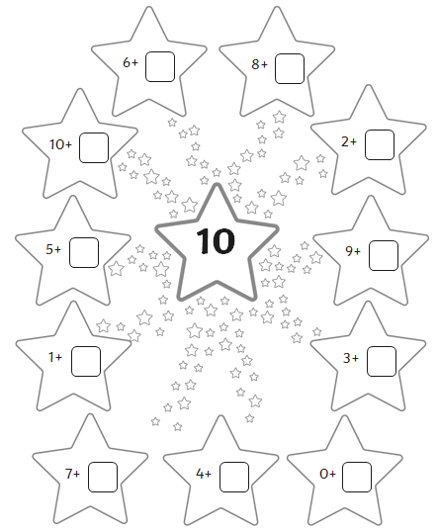
Day 3
Missing Numbers
Fill in the missing numbers from these sections of hundred squares.

14 | 15 |  | 17
 | 25 | 26

23 | 24 |  | 26
33 |  |  | 36

26 | 27
 |  | 38
 | 47
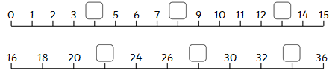

Day 4
Greater Than or Less Than

Put the correct sign (<, > or =) between these numbers.
Remember – the crocodile always eats the bigger number!

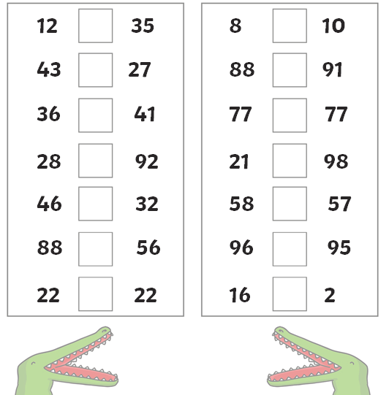

Day 5
10 Times Table Multiplication and Division Challenge

90 ÷ 10 = | 0 x 10 = | 3 x 10 = | 10 x 11 = | 5 x 10 =
10 x 1 = | 20 ÷ 10 = | 10 x 4 = | 2 x 10 = | 30 ÷ 10 =
12 x 10 = | 10 x 5 = | 5 x 10 = | 10 x 9 = | 4 x 10 =
11 x 10 = | 10 x 10 = | 60 ÷ 10 = | 10 x 7 = | 60 ÷ 10 =
10 x 2 = | 8 x 10 = | 9 x 10 = | 40 ÷ 10 = | 12 x 10 =
4 x 10 = | 10 ÷ 1 = | 7 x 10 = | 10 x 0 = | 6 x 10 =
10 x 1 = | 10 x 8 = | 70 ÷ 10 = | 10 x 3 = | 10 x 10 =
10 x 0 = | 12 x 10 = | 5 x 10 = | 8 x 10 = | 3 x 10 =

