Term: Spring 2. | Teacher & Year Group: Miss McInnes, Year 3, Week 4.

As it is Easter, this week’s Home Learning pack is a little different, I have planned some English work, Maths activities and some Art for you to be getting on with.
I hope you all have an amazing Easter, don’t eat too much chocolate.
English |  | Daily Activities.  Monday Bank holiday Monday – spend some quality time with your family. Think of an activity you could all do together. For example: a treasure hunt. The treasure could be kind messages written on paper, hide them around the house or garden and then give clues, using directions, to your family so they know where to find the treasure.  Tuesday Can you create your own acrostic poem using the word Easter? I have attached a picture to remind you what an acrostic poem should look like. You could try to write another one using a word of your choice.  Wednesday Can you draw pictures to complete the Easter story? I have attached a worksheet alongside this, if you are unable to print it, you could rewrite it in your Home Learning Workbook and draw the pictures.  Thursday I have attached an Easter reading comprehension for you to complete it is called ‘Easter Egg-stravaganza!’. Write the answers to each question in your Home Learning Book.  Friday Creative time! Can you design and advertise your own brand new Easter Egg? Think about all the chocolate you like, what would your egg be made up of? It could be milk chocolate with jelly tots and popping candy, filled with marshmallow and candy floss. When you break it hundreds and thousands spill out of the egg. Be as creative as you like! Draw your new Easter Egg and label what it is made up of and then create an advertisement to persuade someone to buy it! You could try to make it with an adult or turn it into a chocolate bar.
Maths |  | Daily Activities.  Monday Bank holiday Monday – spend some quality time with your family. Think of an activity you could all do together. For example: a treasure hunt. The treasure could be kind messages written on paper, hide them around the house or garden and then give clues, using directions, to your family so they know where to find the treasure.  Tuesday Easter Egg Coordinates Worksheet. Remember with coordinates you need to go along the bottom then go up. ‘Into the house then up the stairs ‘  Wednesday I have attached an Easter joke multiplication code breaker worksheet for you to complete. You can do this in your home learning book, answer the times tables and then to find the answer to the joke the letters are at the bottom of the worksheet.  Thursday I have attached an Easter symmetry and pattern worksheet for today. Remember on the symmetry worksheet the pattern needs to be identical on both sides, just like a mirror image. For the pattern worksheet you need to count the Easter Eggs to find out which one is next.  Friday I have attached 2 worksheets for today, mental maths and some word problems. Try your best
Art and  SCARF |  | Here are some different ideas of what you can be doing this week. Take pictures of anything you do to put in your Home Learning Book.  You could cut out an Easter Egg shape and blow paint across it with a straw or use felt tips to create a pattern. Another good technique is to use newspaper or magazine strips.  Use felt tips or colouring pencils to create a 3D Handprint, follow the link to show you how to do it.  https://www.youtube.com/watch?v=YNEXzvnD7mI  Make an Easter card and give it to some special.  As things are a little different at the minute some people might need cheering up, you could create a picture of your own choice with an inspirational quote to make someone smile that day. You could leave it in your window, give to a family member or even post it to a neighbour. Remember to do this safely.
P.E |  | https://www.youtube.com/user/thebodycoach1  Every morning at 9am, Joe Wicks streams a live PE lesson. It is 30minutes long, if you don’t tune it at that time you can access it at any time on his YouTube channel, follow the link above.

English - Wednesday
The Easter Story

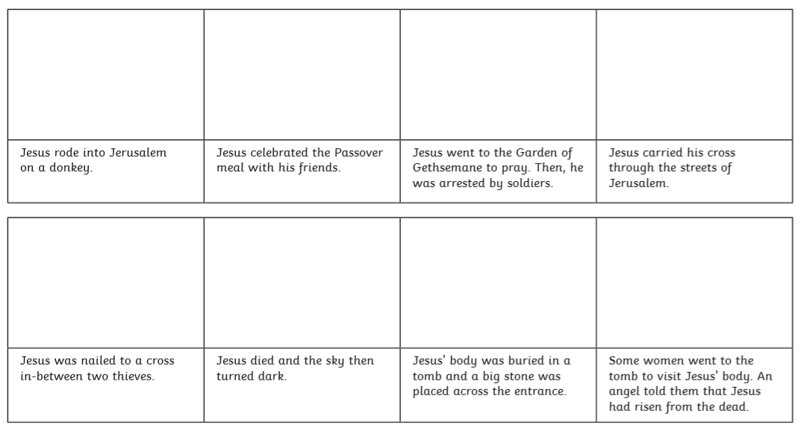

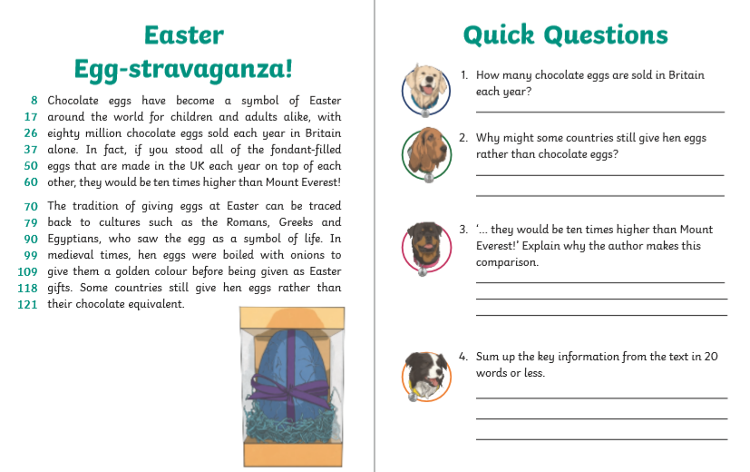
English – Thursday.

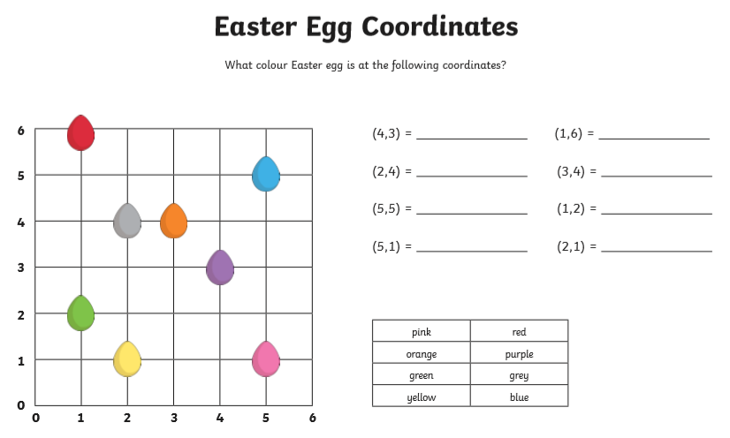
Maths - Tuesday
Purple

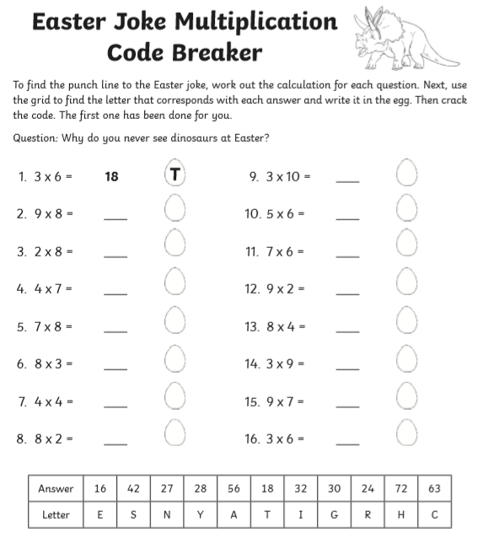
Maths – Wednesday
Remember to practise your times tables on TT Rockstars today!
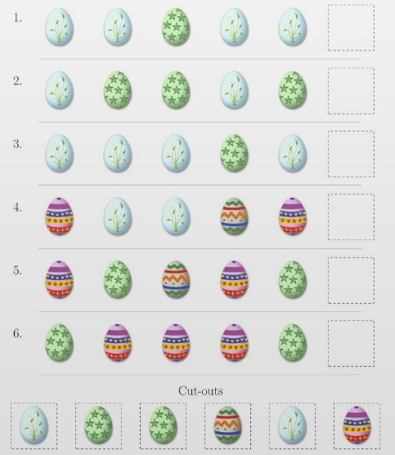
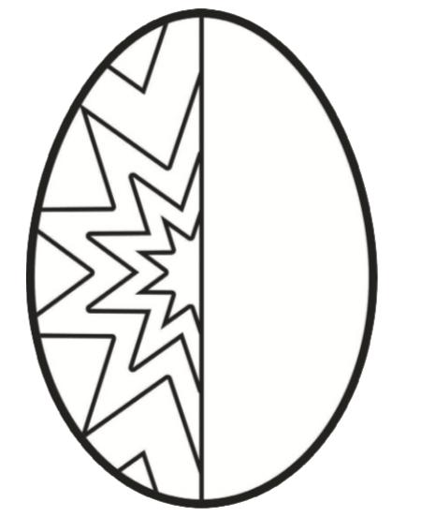
Maths - Thursday
Which Easter egg comes next in the pattern?
If you can print, you can cut and glue the eggs. If you can’t print, draw this into your Home Learning book.
Can you complete the Easter Egg so that the pattern is symmetrical?
If you can’t print, redraw the egg in your Home Learning book. If you found that easy, you could create your own symmetrical pattern on another egg.
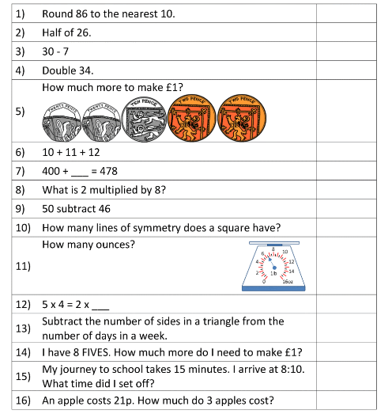
Maths – Friday
Mental Maths
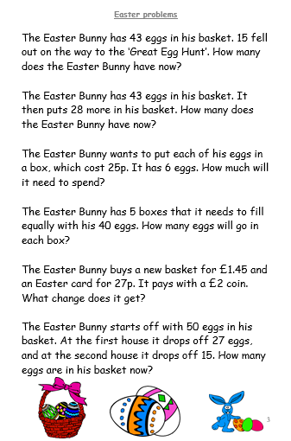
Now try these

