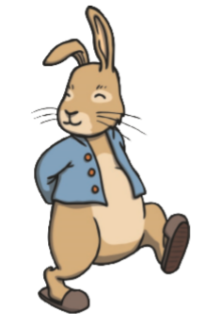
Tuesday
Read the Peter Rabbit book.
Questions to ask your child while reading;
How are the characters feeling?
Can you predict what will happen next?

Help your child with learning the meaning of any unfamiliar words.

Activity
How many little rabbits are in the story?

What are their names?

What did Mrs Rabbit buy from the baker’s?

How did Mr Mcgregor feel when he saw Peter Rabbit eating his vegetables?
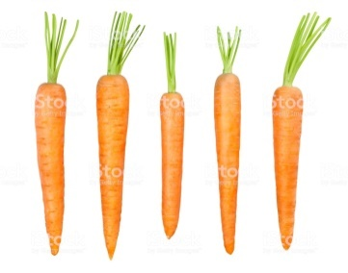
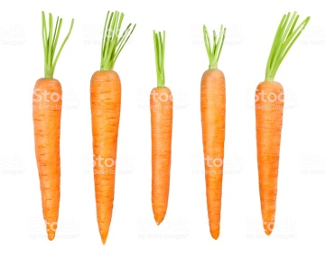
Wednesday

Draw a picture of Peter Rabbit.

Label it with adjectives to describe Peter, maybe you could tell me what kind of rabbit he is, for example;

courageous fast

Thursday
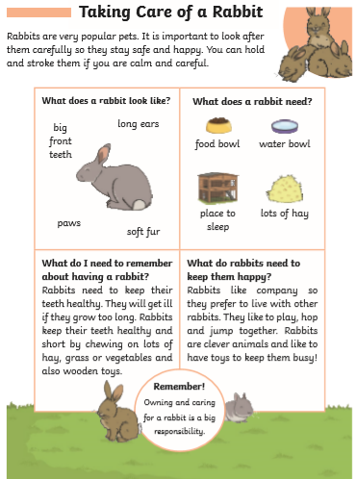

Questions
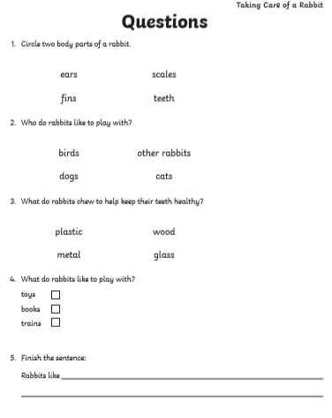

Friday
