Week 3
Tuesday
26
27
28
29
30 | thirty
31
32
33
34
35
36
37
38
39
40 | forty
41
42
43
44
45
46
47
48
49
50
Can you write the word to match the number?
We have done for you.

Wednesday
Number Bonds to 20
Write the missing number to make each star equal to 20.

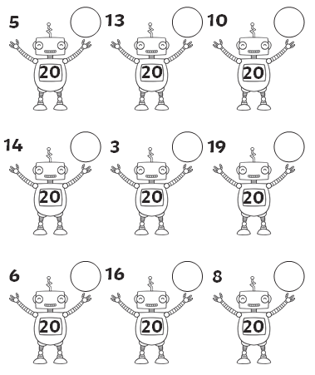

Thursday
Missing Numbers
Fill in the missing numbers from these sections of hundred squares.

54 | 55 |  | 57
 | 65 | 66

53 | 54 |  | 56
63 |  |  | 66

66 | 67
 |  | 78
 | 87

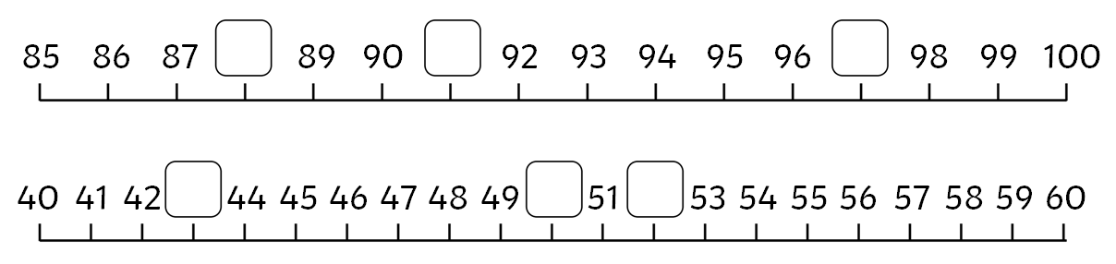

Friday
2 Times Table Multiplication and Division Challenge
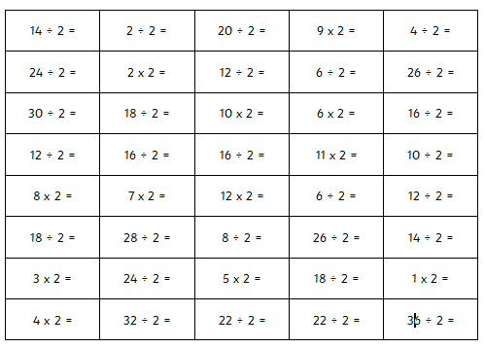

Time yourself, how fast can you go?

