Week 5
Nocturnal Animals
No Printer? No Problem!
• Use the Internet or fact books to research nocturnal and diurnal animals. Children can choose one of each to make a fact file about.
• Use paper plates or paper to make animal masks.
• Make a hedgehog home for spiky nocturnal visitors in your garden, if you have one.
• Listen to different bird calls online. Then, see if your child can recognise them without looking as you play different bird calls.
• Make a night-time picture by drawing with chalks on black paper.
• Can you see any birds from your window? Try using binoculars to get a good look. Children could write a birdwatcher’s diary to record the birds they spot.

Read the e-book before completing the activities, remember it’s ok to help your child with their reading if they are unsure.

Day 1
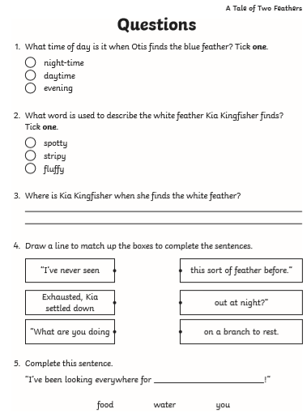

Day 2 - Read the information on Nocturnal animals before answering the questions.
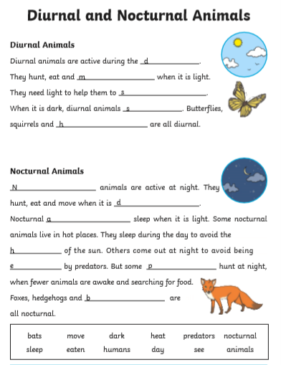

Day 3
- First read the information on nocturnal animals.

- Choose one of the animals to make your own fact file, you can do it any format you want. I have attached an example one that you could use or copy out on to paper.
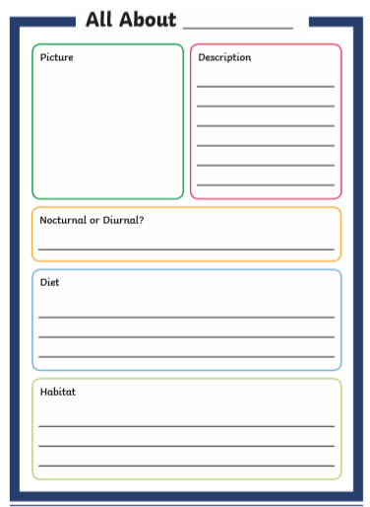

Day 4
Read and follow the instructions to make your own birdfeeder. If you haven’t got some of the ingredients be imaginative try altrnatives.
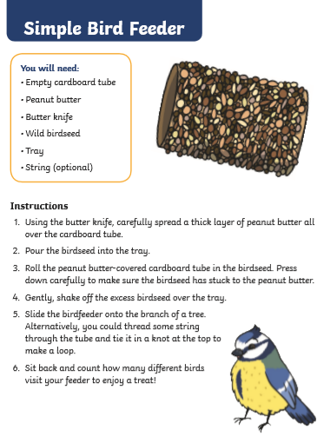

Day 5
Write a review of your bird feeder. Think about the following when you write it.
- Did you follow the instructions?
- Was it easy to make?
- Did you have all the ingredients?
- Did you have to use alternative ingredients?
- What would you change next time?
Bird Feeder Review
Positives
____________________________________________________________________________________________________________________________________________________________________________________________________________________________________________________________________________________________________________________________________________________________________________________________________________________________________________________________________________________________________________________________________________________________

Negatives
____________________________________________________________________________________________________________________________________________________________________________________________________________________________________________________________________________________________________________________________________________________________________________________________________________________________________________________________________________________________________________________________________________________________

