Adding and Subtracting Fractions
Learning Outcomes
Bronze: I can add and subtract fractions with the same denominator (Level 4)
Silver: I can add and subtract fractions with different denominators by changing one fraction (Level 5)
Gold: I can add and subtract fractions with different denominators by changing both fractions (Level 5)


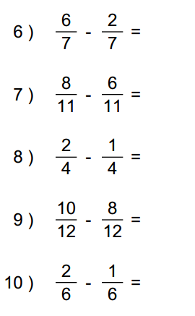
Bronze



Silver
1) 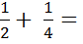 6) 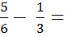
2) 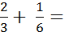 7) 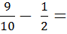

3) 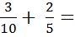 8) 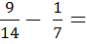
4)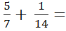 9) 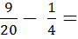
5) 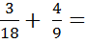 10) 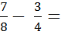
Gold
1) 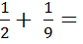 6) 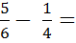
2) 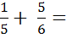 7) 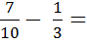

3) 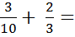 8) 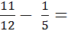
4)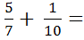 9) 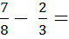
5) 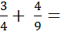 10) 