The Industrial Revolution
In 1837 most people lived in the countryside. They were farmers, or they spun wool and cotton to make cloth. Soon new machines were invented that could do these jobs more quickly. This left many people without work, so they went to find jobs in the new factories.
By the 1850s over half of the population lived in towns and cities.
The Industrial Revolution happened because of the invention of the steam engine. Victorian engineers made bigger, faster and more powerful machines that could run whole factories. There was a large increase in the number of factories (particularly textiles factories or mills).
In 1856 a way of changing iron into steel was invented. Ships, bridges and buildings could now be built bigger and more quickly.
Factory and business owners became very rich. However, the people working the machines in the factories were very poor.
Most cities and towns were not prepared for the large number of people looking for a home near their workplace. Many people had to share a room in someone else’s house. Rooms were rented to whole families. Often ten or twelve people shared one room.
Some factory owners built houses for their workers. The houses were built close together. They were not always big enough for large families.
The houses did not have running water and toilets. Up to 100 houses had to share an outdoor water pump and an outside toilet.
Many factory owners put money above the health and safety of their workers. Children and young women were employed in terrible conditions. Working hours were long and there were no holidays.
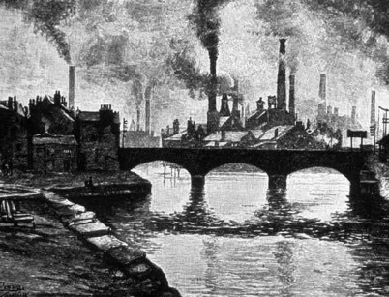
Name ……………………………………………………………………… Date …………………

Questions

- Where did most people live at the start of the Victorian era?
……………………………………………………………………………………………………………………………………………

- What jobs did they do?
……………………………………………………………………………………………………………………………………………

- What was invented that could do these jobs more quickly?
……………………………………………………………………………………………………………………………………………

- What happened to the people that were doing the jobs?
……………………………………………………………………………………………………………………………………………

- What did they have to do?
……………………………………………………………………………………………………………………………………………

- Who became very rich?
……………………………………………………………………………………………………………………………………………

- Which people were poor?
……………………………………………………………………………………………………………………………………………

- What does the text tell us about poor people’s:
houses? ........................................................................................................................
……………………………………………………………………………………………………………………………………………
……………………………………………………………………………………………………………………………………………

toilets? ........................................................................................................................
……………………………………………………………………………………………………………………………………………
……………………………………………………………………………………………………………………………………………

working conditions? ................................................................................................
……………………………………………………………………………………………………………………………………………
……………………………………………………………………………………………………………………………………………

