English Year 1 and 2
Hello year one and two, we hope you are enjoying the time with your families. We are missing you so much and can’t wait to be back in the classroom. Remember to enjoy lots of reading time and using the logins from the back of your diaries for the different apps/websites. Here are some lessons for each day to keep you busy, but what we want most of all is for you spend time doing things that make you happy.
The True Story of the Three Little Pigs
Monday | Following on from our work about the Three Little Pigs, this week we are going to look at ‘The Wolf’s True Story’ which tells the story from the wolf’s perspective.  Watch and listen to the story on youtube:  https://www.youtube.com/watch?v=vB07RfntTvw  When you have watched the story, talk through some of the differences in this story and the original story of the three little pigs. Who is the villain in this story? Who is innocent? Which story do you believe?  TASK – Create a story map of ‘The True Story of the Three Little Pigs’. The children have done lots of these in class, the idea is to retell the story in small images with few words – like the one below.  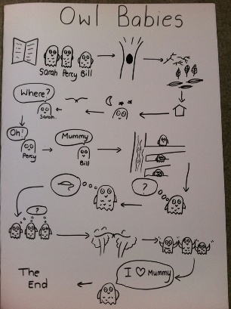
Tuesday | Over the next three days we would like you to retell the story in stages. Use the story map to help you. We would like you to think about how the characters are feeling, you might want to use speech for what they might be saying to one another.  TASK – Write the beginning of the story. The beginning starts to introduce us to the characters and the setting of the story. You may want to write up to the point of the Wolf going to the first pig’s house and knocking it down.
Wednesday | Revisit the beginning of the story from yesterday – is there anything else you would like to add? Are there any bits you would like to change to make it even better? Next we are going to look at the middle of the story. This is where problems start to appear and the action of the story takes place.  TASK – Write the middle of the story where things start to go wrong – the wolf starts eating the pigs by ‘accident’’. What are some of the things he might say? You might want to write up to the point of the wolf sneezing at the brick house, because this is when things begin to change and the ending falls into place.
Thursday | Again, revisit what you have written so far for your story. Are there any bits that you would like to change to make it even better?  TASK – Write the end of the story. Think about how to pig might have been feeling inside the house, how was the wolf feeling? Why was he so upset? What did the news reporters do?
Friday | BOOK OF THE WEEK  Your teachers are really missing class reading time and listening to you read. We would like you to use this day to tell us about a book you have read this week. What was your favourite part? Who were the characters? What would you rate your book on a 5 star rating? You may want to draw a new front cover for your book too!

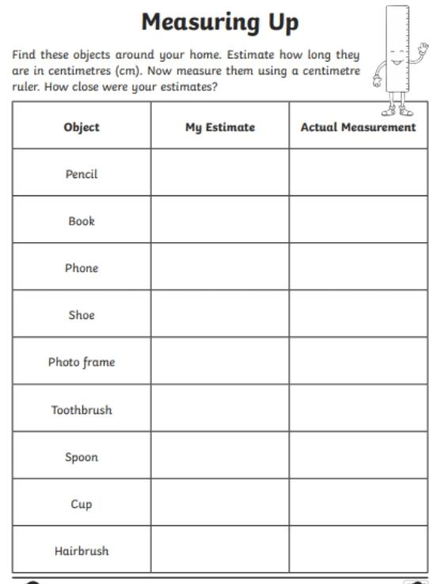
Maths
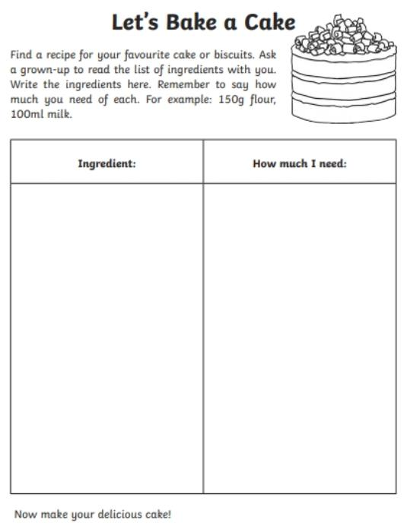
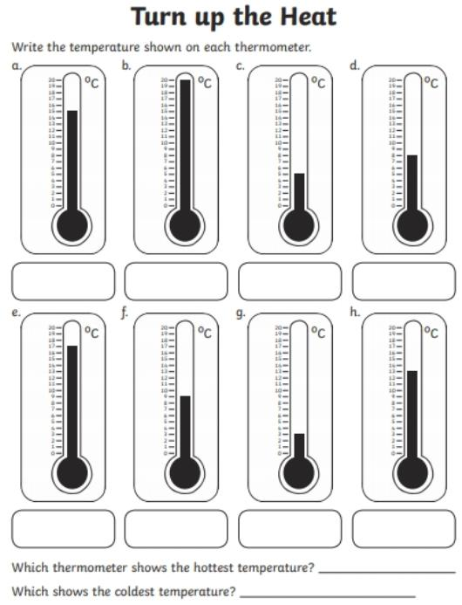
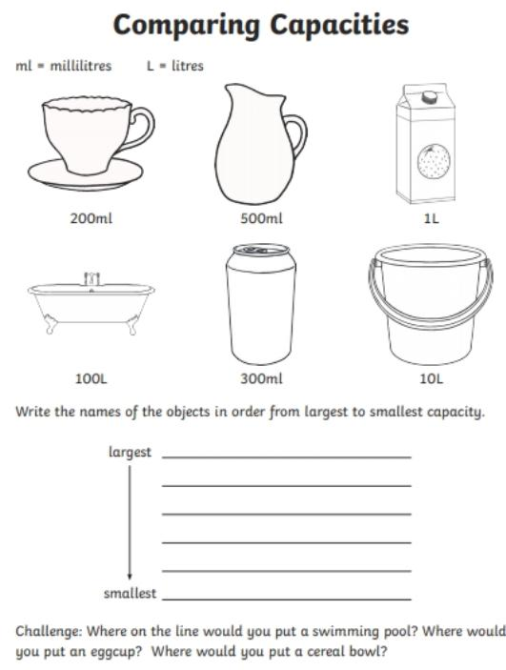
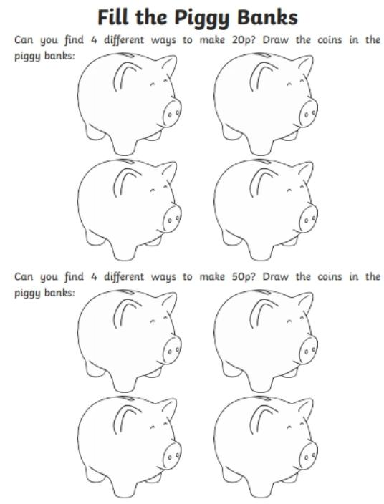
VE Day
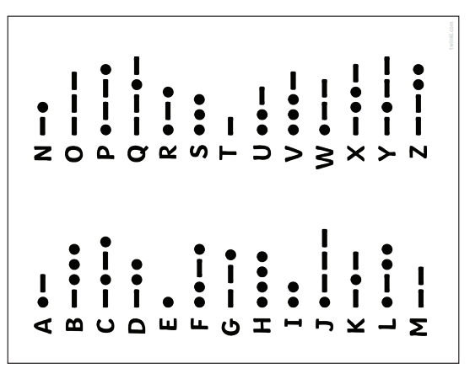
Use the Morse code to decipher this message.
. . . _
.
_ . .
. _
_ . _ _

Morse code is a way of sending messages in the war. Use the Morse code to make your own secret message.
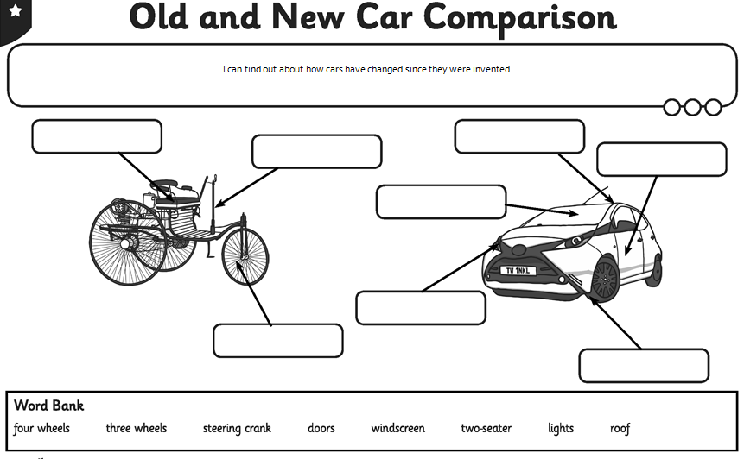
History
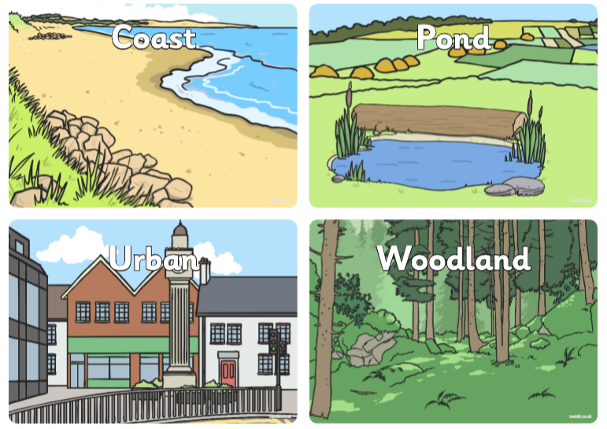
Science
