CAPTAIN TOM – A VERY BRITISH HERO

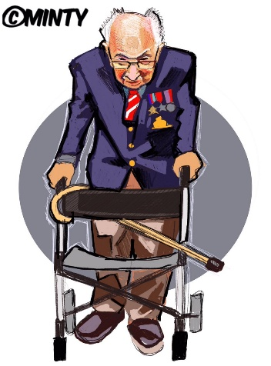
On April 6th 2020, at the age of 99, a fellow called Tom Moore began to walk around his garden in order to raise money for charities connected with the NHS (The NHS Charities Together). His goal was to do one hundred laps of the garden and to raise £1,000 by his hundredth birthday, on April 30th. People began donating money and by the morning of his birthday, incredibly, he had raised over £30 million. Captain Tom has made many media appearances and he has become a popular household name in the United Kingdom. People have become very interested in his life story. Captain Tom joined the Army when he was just seventeen and fought in the Second World War. He wears his medals with pride.
Originally from West Yorkshire, he now lives with his daughter in Bedfordshire. One of the Captain’s heroes is Michael Ball and that singer got in touch with him via Breakfast TV. Together, they released a cover version of the song "You'll Never Walk Alone", with proceeds going to the NHS charity. The single has now topped the UK music charts and made him the oldest person to achieve a UK number one. In doing so, he has relegated another of his heroes, Dame Vera Lynn, aged 103, to second place. She sent Captain Tom a kind message, but the veteran wouldn’t say what she had said exactly. Always the English gentleman!
Captain Tom has received over 175,000 cards for his 100th birthday, which are being stored in a school assembly hall. He has had a flypast – with Spitfires, of course – on the morning of his special birthday. He has been appointed an honorary colonel of the Army Foundation College and has received special messages from the Queen, Prime Minister Boris Johnson and many others.
Colonel Tom has broadcast many uplifting messages to the nation, assuring everybody what we will beat this virus. We must remain positive and we will overcome, he says. He is currently enjoying a well-deserved rest, but I think we will be hearing much more from this inspirational centenarian, who the nation has taken to its heart.
Answer the questions about the Captain Tom phenomenon. Answer in full sentences.
- What was Captain Tom’s initial intention?
The NHS = The National Health Service
- How long did it take for the donations to reach the £30 000 000 mark?
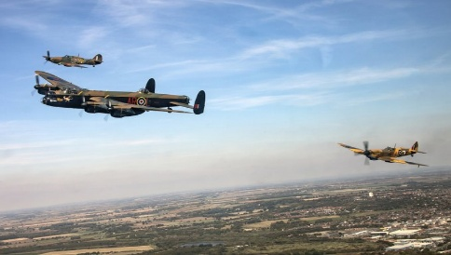
- Clearly many people sponsored the Captain. How did they find out about him?
- How long ago did he join the Army?
- Where does he come from?
- What have he and Michael Ball done together and why?
- Who has sent the Captain messages and why?
- What messages has Captain Tom expressed to the British people?
- What is he doing now?
- What is a centenarian?
Over to you:
Do you find this story strange or uplifting? Does it reveal/say anything about the British character, or could this happen anywhere?
Research: Who is Dame Vera Lynn? Write a paragraph about her.
Why do you think her record is #2 in the UK charts?
Spitfires: write a short paragraph about them.

https://www.youtube.com/watch?v=LcouA_oWsnU

‘You’ll Never Walk Alone’ By Gerry and the Pacemakers, sung by Michael Ball and Colonel Tom Moore.
Listen /watch and replace the missing words.
When you walk through a _________
Hold your _______ up high
And don't be _______ of the dark
At the _______ of a storm
There's a golden sky
And the sweet _______song of a lark
Walk on through the _______
Walk on through the _______
Though your _______ be tossed and blown
Walk on, walk on
With ______ in your heart
And you'll ______ walk alone,
No, you’ll never walk alone.
End, wind, Storm, hope, afraid, head, rain, silver, never, dreams,

-----------------------------------------------------------------------------------------------------------------------------
Read the following passage, about the song and replace the missing words.
FYI: ‘’You'll Never Walk Alone" is a show 1. _______ from the 1945 Rodgers andHammerstein musical Carousel. In the second 2. ______of the musical, Nettie Fowler, the cousin of the protagonist Julie Jordan, sings "You'll Never Walk Alone" to comfort and 3. _________ Julie when her husband, Billy Bigelow, the male lead, falls on his knife and 4.________ after a failed robbery attempt. It is reprised in the 5._________ scene to encourage a graduation class of which Louise (Billy and Julie's daughter) is a member. The now 6.________ Billy, who has been granted the chance to return to Earth for one 7.________ in order to redeem himself, watches the ceremony and is able to silently motivate the unhappy Louise to join in the 8._________.
The song is also sung at association football 9.________ around the world, where it is performed by a massed chorus of supporters on match day; this tradition developed at Liverpool FC after the chart success of the 1963 10._________ of the song by the local Liverpool group Gerry and the Pacemakers, and it is considered a theme song of Liverpool FC more so than any other team.
In some areas of the UK, "You'll Never Walk Alone" became the 11._________ of support for medical staff, first responders, and those in quarantine during the coronavirus 12._________. It is now at Number 1 in the UK charts, sung by Michael Ball and Captain 13.________ Moore.
Dies, Tune, invisible, clubs, encourage, act, final, single, pandemic, day, song, Tom, anthem

You can order a pin of the Captain Tom clipart from here:
https://aguycalledminty.co.uk/products/the-captain-tom-moore-pin-badge-preorder?variant=31884261916720

Key for gap fill
‘’You'll Never Walk Alone" is a show tune from the 1945 Rodgers and Hammerstein musical Carousel. In the second act of the musical, Nettie Fowler, the cousin of the protagonist Julie Jordan, sings "You'll Never Walk Alone" to comfort and encourage Julie when her husband, Billy Bigelow, the male lead, falls on his knife and dies after a failed robbery attempt. It is reprised in the final scene to encourage a graduation class of which Louise (Billy and Julie's daughter) is a member. The now invisible Billy, who has been granted the chance to return to Earth for one day in order to redeem himself, watches the ceremony and is able to silently motivate the unhappy Louise to join in the song.
The song is also sung at association football clubs around the world, where it is performed by a massed chorus of supporters on match day; this tradition developed at Liverpool FC after the chart success of the 1963 single of the song by the local Liverpool group Gerry and the Pacemakers, and it is considered a theme song of Liverpool FC more so than any other team.
In some areas of the UK, "You'll Never Walk Alone" became the anthem of support for medical staff, first responders, and those in quarantine during the 2019–20 coronavirus pandemic. It is now at Number 1 in the UK charts, sung by Michael Ball and Captain Tom Moore.

