English Year 1 and 2: Mon – Thurs work based upon The Gingerbread Man
Monday | What is a traditional tale? It is a story that has been retold for many years and therefore most people know. Things can change slightly between different versions but the tale mainly stays the same. We have looked at the traditional tale of The Three Little Pigs, this week we are going to look at The Gingerbread Man. Share the story together –  https://www.youtube.com/watch?v=pckuS--UlV4  Write a newspaper report like the one on the next page – remember to include a headline!
Tuesday | Mr Fox has been arrested by the policed for eating The Gingerbread Man! He must come up with a reason as to why he ate the gingerbread man but what could he say? Think about The Wolf’s True Story from last week when he kept sneezing and ‘accidentally’ blowing the pigs houses down. What could Mr Fox’s excuse be? Did the Gingerbread Man accidentally slip into his mouth? Was it already too late so he thought he may as well enjoy eating him anyway? Maybe it was the Gingerbread Man actually jumped into Mr Fox’s mouth?  Write a statement from Mr Fox to the police about why he ate The Gingerbread Man – you might want to draw pictures.
Wednesday | Discuss what happens at the end of this story, is it a happy ending? What might have been a happier ending? Today you are going to write a different ending for the story. There are lots of different characters in the story that you might want to include in the ending. Could the fox be kind to The Gingerbread Man but then the old lady catches up with him? Could The Gingerbread Man find a group of friends to live happily ever after with? Write your new ending in your home school book, we can’t wait to read them!
Thursday | Think about the different stages in the story, what are the important things that happen? In your home school books, split your pages into 6-8 boxes to create a comic strip. Draw the different events of the story in each of the boxes and include speech bubbles to retell the story. You may also want to include thought bubbles to write what the characters might be thinking or feeling. If you like, you could use this comic strip to re-write the story in your own words.
Friday | Watch and share the PowerPoint ‘Making Decisions’. The PowerPoint is all about different decisions we might make and people who can help us to make them In your Home Learning book, try some of the activities from the slides. You could draw a table like the one on slide 5 to think of some different decisions you might make at home and at school. Think about the different people who could help you with your decisions such as your family, friends and teachers.

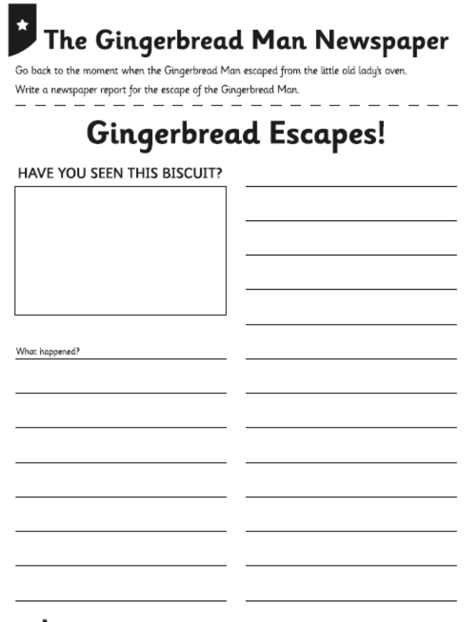

History of Transport
Trains
Watch this video about George Stephenson who invented the first steam locomotive for transporting coal.
https://www.youtube.com/watch?v=P6a4zDjLAlY
Watch a short clip of this video https://www.youtube.com/watch?v=mDW_Vm31opg
Now listen to The Train Ride story
https://www.youtube.com/watch?v=Ao_z_G_BqiQ
Now imagine that you are in 1830 and it is your first ever train ride. Write an account of what you can see and how you felt.
Science- Living Things and their Habitats
We are going to continue looking at minibeasts.
Can you choose a minibeast to research and create a fact file about that creature? Remember to look at its features, diet and habitat. You can also include pictures and diagrams.
Challenge: Can you compare with another type of minibeast and look for similarities and differences?

RE- Jesus is special
Watch The Blind Beggar Bible story
https://www.youtube.com/watch?v=X4qZ2KSbdxI
Can you write about a time when you needed help. Who helped you? How did you feel?
Now write about a time when you helped someone who needed help.

Design technology- Can you design a vehicle using axles and wheels.
When you have designed it you may want to have a go at creating a model of it.

Now look at the PowerPoint on making decisions and complete the next two activities on the following pages.

Remember all your work can be written on paper if you do not have a printer

If you could have a snack, would you rather…
 | Or
An Apple ☐ |  | An Orange ☐
If you could have a new pet, would you rather…
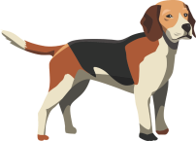 | Or | 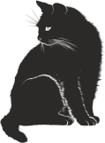
A dog? ☐ |  | A cat? ☐
If you could have a day out, would you rather…
 | Or | 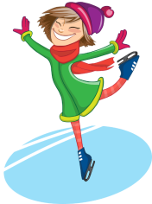
Go to the zoo? ☐ |  | Go ice skating? ☐
If you could stay up late, would you rather…
 | Or | 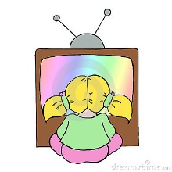
Read a book? ☐ |  | Watch a cartoon? ☐
If you could have something sweet, would you rather…
 | Or
Ice cream ☐ |  | Sweets ☐
Which do you prefer doing,
 | Or
Chatting on the phone ☐ |  | Listening to music ☐
Resource 1 – Would you rather?

